# Agenda

**Big Data Analytics: Hadoop**

1. Big Data Challenges
2. Hadoop
3. Core Hadoop Components
4. Hadoop Ecosystem
5. Limitation of Hadoop

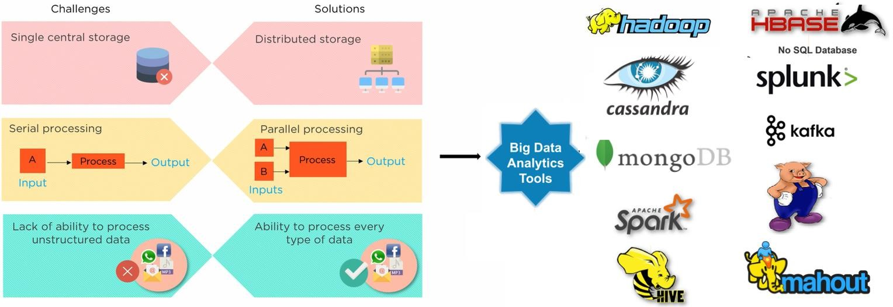

|  |  |  |
| --- | --- | --- |
| **Challenges** | **Solutions** | **Tools** |
| **Volume:** Single storage system-  Managing and processing massive amounts of  data that exceed the capacity of traditional data processing systems. | Distributed Computing and Storage | **Hadoop**: HDFS for distributed storage and MapReduce for parallel processing. |
| **Velocity:**  Processing and analyzing streaming data in real-time as it's generated | Stream Processing | **Apache Spark**: Offers in-memory processing for iterative algorithms and interactive data analysis.  **Apache Kafka**: Enables real-time data pipelines and stream processing.  Apache Flink: Event-driven applications that need low-latency and high- throughput processing |
| **Variety:**  Dealing with diverse data types and formats (structured, semi-structured, unstructured). | NoSQL  database & processing tools | **HBase**: A NoSQL database that provides real-time access to unstructured and semi-structured data, particularly suited for random read/write operations.  **MongoDB**: A document-oriented NoSQL database that is flexible for storing unstructured and semi-structured data.  **Cassandra**: A distributed NoSQL database designed for handling large amounts of  structured and unstructured data with high availability.  **Apache Hive**: A data warehousing for analyzing structured data in Hadoop.  **Spark SQL**: SQL queries on structured and semi-structured data, including JSON and Parquet files. |

|  |  |  |
| --- | --- | --- |
| **Challenges** | **Solutions** | **Tools** |
| **Veracity:**  Ensuring the accuracy and quality of the data, dealing with incomplete or noisy data | Data Quality and Cleansing | **Trifacta**: A data wrangling tool for clean, transform, and enrich data for analytics.  **Talend**: ETL tool that helps with data quality and governance |
| **Value:**  Extracting meaningful insights and value from the data. | Advanced Analytics and Machine Learning | **Apache Mahout**: machine learning algorithms that can be used with Hadoop.  **Spark MLlib**: machine learning algorithms library used with Spark |
| **Variability:**  Handling data that exhibits fluctuations in  volume and characteristics | Scalability and Elasticity | **Docker and Kubernetes**: Containerization and orchestration tools that allow applications to be deployed and scaled easily.  **Amazon EC2 Auto Scaling**: Automatically adjusts the number of EC2 instances  based on load for Amazon Web Services (AWS) applications |

Hadoop is an open-source framework that manages big data storage in a distributed way and process it

parallelly.

* 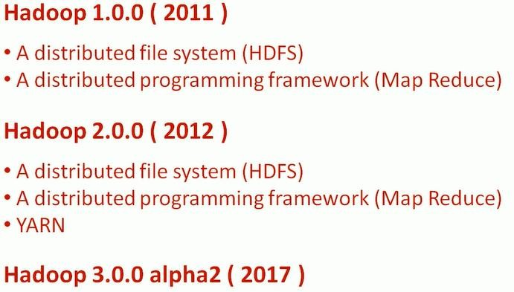Distributed **Data storage** and

**processing environment**.

* **Uses** commodity hardware
* Developed by: **Apache Software** Foundation in Dec, 2011 (based on google white paper)
* Written in: JAVA
* Current stable version: Hadoop 3.11

Hadoop mainly have three component-HDFS, YARN and MapReduce

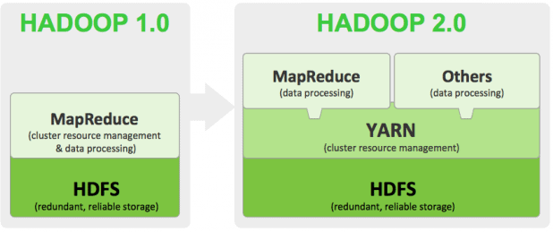

* HDFS stands for Hadoop Distributed File system.
* HDFS is specially designed for storing huge datasets in commodity hardware.
* Stored different types of data i.e., structured, unstructured, and semi-structured in a distributed way.
* 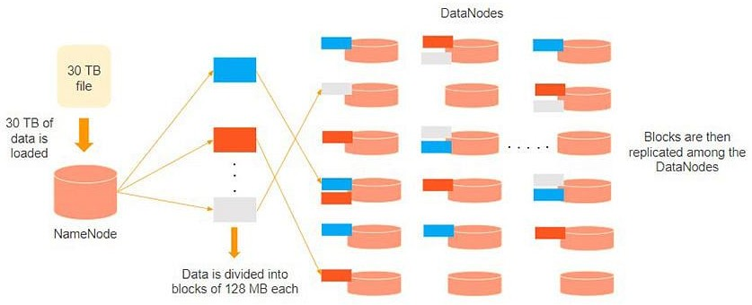There are two components of HDFS - name node and data node. While there is only one name node, there can be multiple data nodes.

# YARN (Yet Another Resources Negotiator): Resource Manager

* YARN stands for Yet Another Resources Negotiator.
* 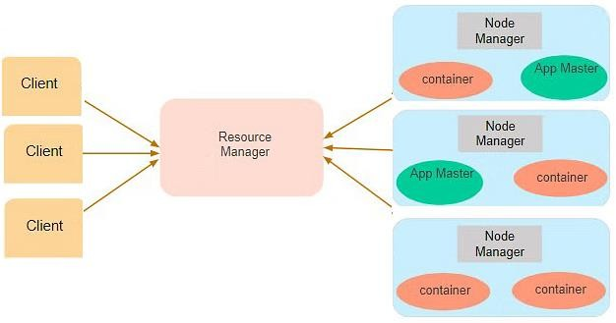Performs all processing activities by allocating resources ( RAM, Memory, etc.) and scheduling tasks.

### the most important component of YARN is:

1. **Resource manager**: manages resources and schedule

the application running on top of YARN.

1. **Node Manager**: It is the slave of YARN Architecture. Each Node Manager receives instructions from the Resource Manager and reports and handles containers on a single node. It manages container lifecycle, node health, log management, Node, and container resource usage
2. **Application Master**: It is a framework-specific library that negotiates resources from the Resource Manager and works with the Node Manager or manages to execute and monitor containers and their resource consumption.

* MapReduce is a framework used for writing applications that process large data sets in a distributed manner with parallel algorithms.
* Map reduce have two functions: Map() and Reduce()
* Map function performs actions like filtering, grouping, and sorting.
* Reduce function aggregates and summarizes the results produced by the map function.

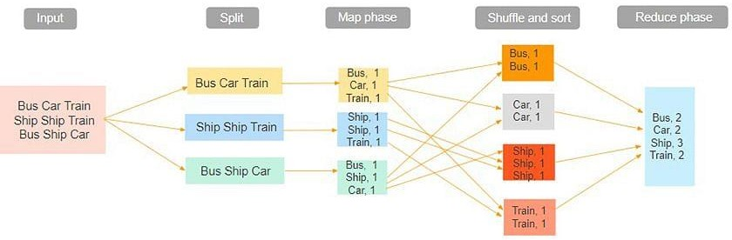

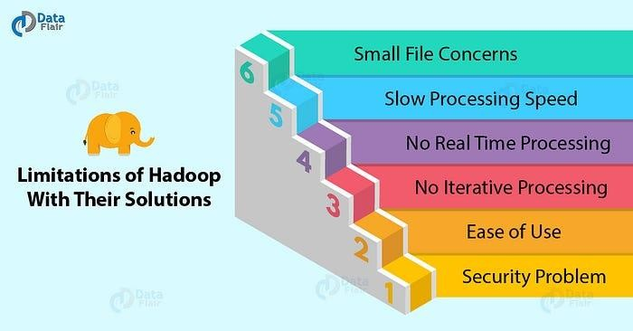

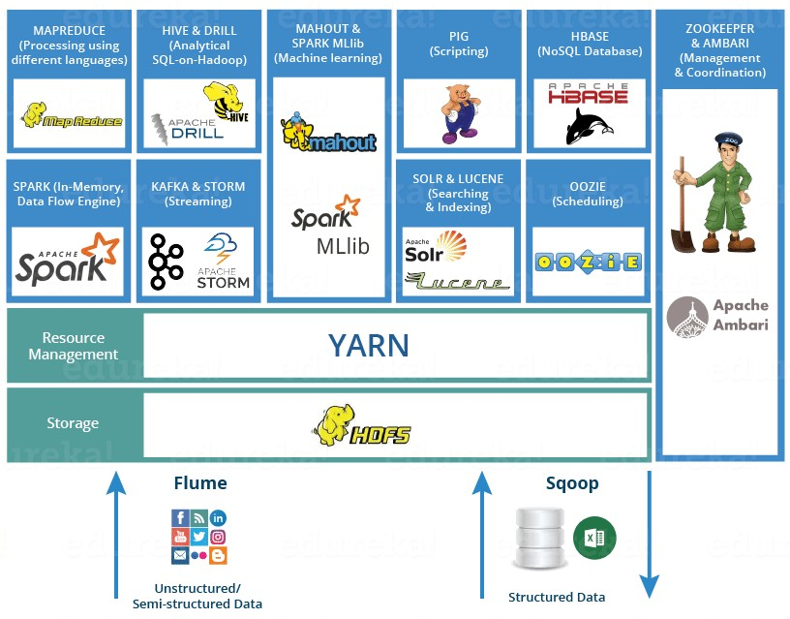

* + Hive is a data warehouse system that is used to query (reading, writing, managing) and analyze large datasets stored in the HDFS.
  + Developed by Facebook to reduce the task of writing complex queries in Map Reduce.
  + Hive uses a query language called HiveQL (HIVE Query Language)., which is similar to SQL.
  + 2 basic components: Hive command line and JDBC/ODBC driver.
  + Used by analyst.
  + Works on structured data but does not work on other types of data.

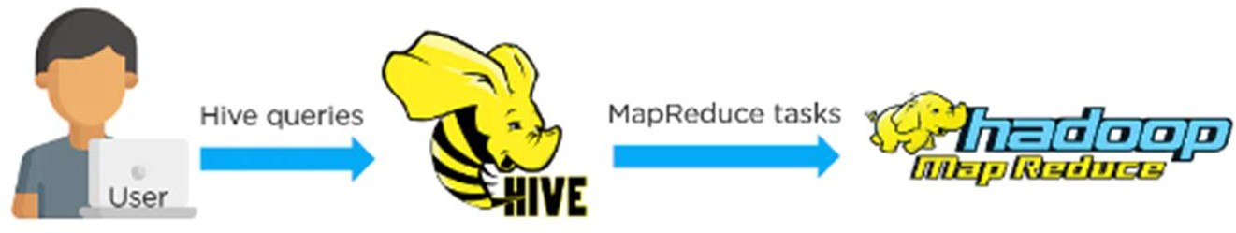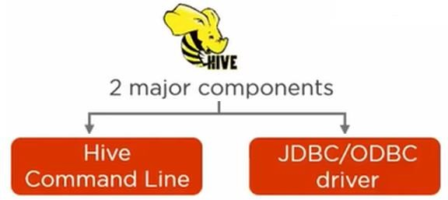

Pig is a scripting platform that runs on Hadoop clusters, used to process and analyze large datasets.

•

•

•

•

•

•

•

Developed by Yahoo to reduce to task of writing complex queries in Map Reduce. 1 line of pig = approx. 100 lines of Map reduce job.

Pig scripting language is called Pig Latin.

Works on structured, semi-structured, and unstructured data.

Used by Programmers and researchers.

2 basic components: Pig Latin (Pig language) and the pig runtime (for the execution environment).

* It gives you a platform for building data flow for ETL (Extract, Transform, and Load).

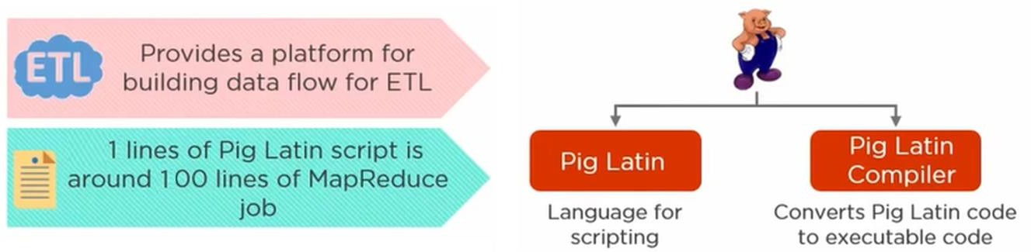

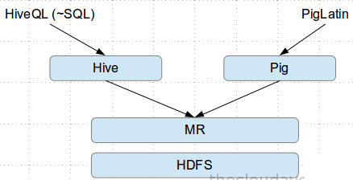

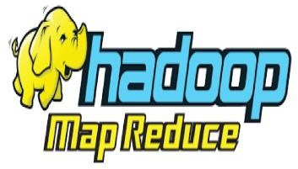  

* Compiled Language
* Language: Java
* Lower level of abstraction
* More lines of code
* More development effort is involved
* Code efficiency is high when compared to Pig and Hive.
* SQL-like query language.
* Language: HiveQL (declarative SQLish language)
* Ex: select * from ‘mytable’ ;
* Higher level of abstraction
* Comparatively fewer lines of code than MapReduce and Pig.
* development effort is less.
* Code efficiency is relatively less.
* Hive is used by Analysts, generating daily report.
* Scripting Language
* Language: PigLatin (Procedural data-flow language)
* Ex: A = load ‘mytable’;
* dump A;
* High level of abstraction
* Comparatively fewer lines of code than MapReduce
* development effort is less.
* Code efficiency is relatively less.
* Pig is used by Programmer and Researchers.

|  |  |  |
| --- | --- | --- |
|  | **Pig** | **Hive** |
| Used by | Mainly used by Researchers and Programmers | Mainly used by Data Analysts |
| Application | Pig mainly used by Programmers and  researchers. | Hive mainly used by Analysts, generating daily report. |
| Language type | Procedural Data Flow Language | Declarative SQLish Language |
| Used language | PigLatio  Ex: A = load ‘mytable’ ;  dump A; | HiveQL  Ex: select * from ‘mytable’ ; |
| Developed by | Yahoo | Facebook |
| Works on | Structured, semi-structured, and Unstructured  data | Work on only Structured data. |
| Avro support | Pig support Avro File format | Hive does not support the Avro File format |
| Partition support | Pig does not support partitions although there is  an option for filtering. | Hive support partitions. |
| Operates on | Operates on the client side of a cluster. | Operates on the server side of a cluster. |
| Web interface | Pig does not support we interface. | Hive support web interface |

* + 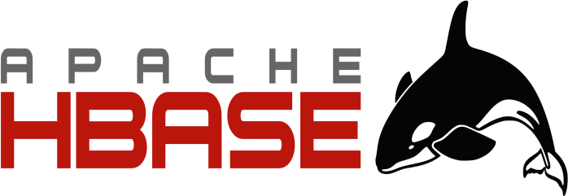HBase is an open-source **column-oriented non-relational database management system (**NoSQL database) that runs on top of Hadoop Distributed File System (HDFS).
  + 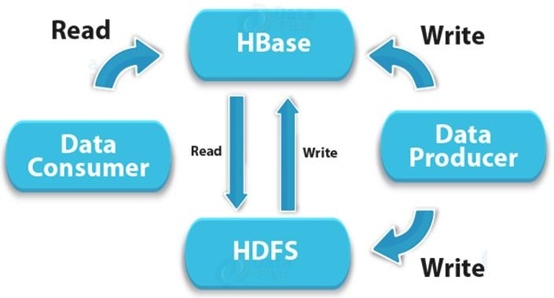HBase provides a fault-tolerant way of storing sparse data sets, which are common in many big data use cases.
  + Supports all types of data and that is why, it’s capable of handling

anything and everything.

* + It is written in JAVA and HBase applications can be written in REST, Avro, and Thrift APIs.
* Spark is an open-source framework for real-time data analytics in distributed computing

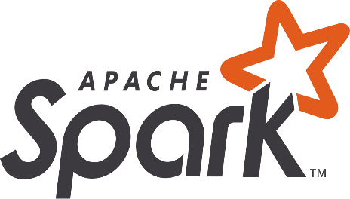environment.

* Written in Scala and was originally developed at the University of California, Berkeley.
* It executes in-memory computations to increase the speed of data processing over MapReduce.
* 100x faster than Hadoop for large-scale data processing by exploiting in-memory computations. Therefore, it requires higher processing power than Map-Reduce

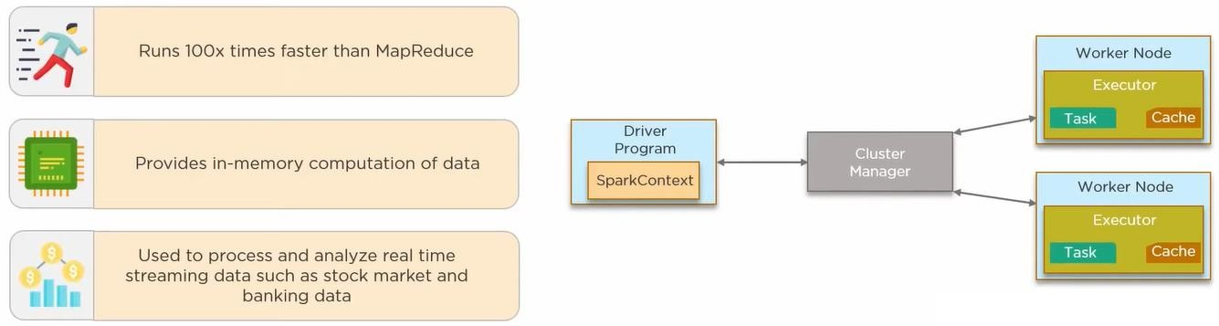

08-10-2024

18

* 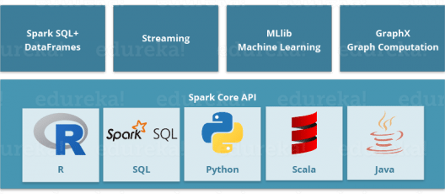Spark comes packed with high-level libraries, including support for R, SQL, Python, Scala, Java, etc.
* These standard libraries increase the seamless integration in complex workflow.

***“Apache Spark: A Killer or Savior of Apache Hadoop?” – O’Reily***

* + Answer: This is not an apple-to-apple comparison. Apache Spark best fits for real-time processing, whereas Hadoop was designed to store unstructured data and execute batch processing over it. When we combine both, i.e., Apache Spark’s ability high processing speed, advanced analytics, and multiple integration support with Hadoop’s low-cost operation on commodity hardware, it gives the best results.
  + That is the reason why, Spark and Hadoop are used together by many companies for processing and analyzing the Big Data stored in HDFS.
  + It’s an open-source application that works with distributed environments to analyze large data sets.
  + As the name suggests, Apache Drill is used to drill into any kind of data.
  + the main power of Apache Drill lies in **combining a variety of data stores just by using a single query**.
  + It supports different kinds of NoSQL databases and file systems, which is a powerful feature of Drill. For example Azure Blob Storage, Google Cloud Storage, HBase, MongoDB, MapR-DB HDFS, MapR-FS, Amazon S3, Swift, NAS, and local files.
  + Apache Drill basically follows the ANSI SQL.
  + It is a replica of Google Dremel.

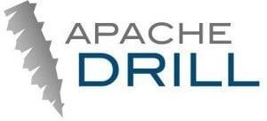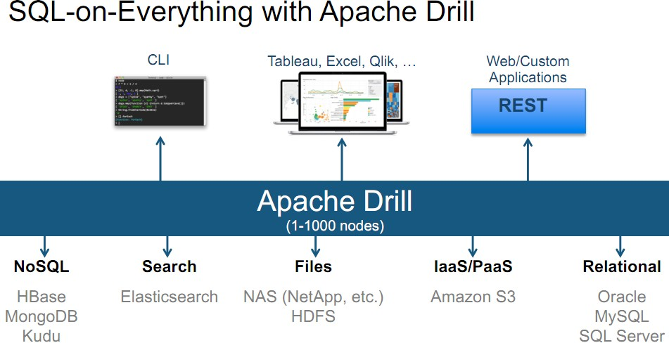



* + - Mahout provides an environment for creating machine learning applications that are scalable.
    - Mahout provides a command line to invoke various Machine learning algorithms. It has a

defined set of libraries that already contains different inbuilt algorithms for different use cases.

* + - It performs **collaborative filtering, clustering, and classification.**
      * Apache Zookeeper is the coordinator of any Hadoop job which includes a combination of

various services in a Hadoop Ecosystem.

* + - * Before Zookeeper, it was very difficult and time-consuming to coordinate between different services in the Hadoop Ecosystem.
      * The services earlier had many problems with interactions like common configuration while synchronizing data. Even if the services are configured, changes in the configurations of the services make them complex and difficult to handle. The grouping and naming were also a time-consuming factor.
      * Due to the above problems, a Zookeeper was introduced. It saves a lot of time by performing synchronization, configuration maintenance, grouping, and naming.



* + Apache Oozie as a clock and alarm service inside the Hadoop Ecosystem. For Apache jobs, Oozie has been just like a scheduler. It schedules Hadoop jobs and binds them together as one logical work.
  + There are two kinds of Oozie jobs:
  1. Oozie workflow: These are sequential set of actions to be executed.
  2. Oozie Coordinator: These are the Oozie jobs that are triggered when the data is made available to it.
     + The Flume is a service which helps in ingesting unstructured and semi-structured data into

HDFS.

* + - It gives us a solution that is reliable and distributed and helps us in collecting, aggregating, and moving large amount of data sets.
    - It helps us to ingest online streaming data from various sources like network traffic, social

media, email messages, log files, etc. in HDFS.

## the flume agent has 3 components: source, sink, and channel.

1. **Source**: it accepts the data from the incoming streamline and stores the data in the channel.
2. **Channel**: it acts as the local storage of the primary storage. A Channel is a temporary storage between the source of data and persistent data in the HDFS.
3. **Sink**: Then, our last component i.e. Sink, collects the data from the channel and commits or writes the data in the HDFS permanently.



* + - Sqoop is also a data ingesting service.
    - the major difference between Flume and Sqoop is that:
* Flume only ingests unstructured data or semi-structured data into HDFS.
* While Sqoop can import as well as export structured data from RDBMS or Enterprise data warehouse to HDFS or vice versa.

 

Apache Solr and Apache Lucene are the two services that are used for searching and indexing in Hadoop

Ecosystem.

* + Apache Lucene is based on Java, which also helps in spell-checking.
  + If Apache Lucene is the engine, Apache Solr is the car built around it. Solr is a complete application built around Lucene.
  + It uses the Lucene Java search library as a core for search and full indexing.
  + Core component in a Hadoop Ecosystem for processing.
  + Help in writing an application that processes large data sets using distributed and parallel algorithms.
    - Ambari is an Apache Software Foundation project which aims at making the Hadoop ecosystem more manageable.
    - the Ambari provides software for provisioning, managing, and monitoring Apache Hadoop cluster.

### Hadoop cluster provisioning:

* + It gives us step by step process for installing Hadoop services across a number of hosts.
  + It also handles the configuration of Hadoop services over a cluster.

### Hadoop cluster management:

* + It provides a central management service for starting, stopping, and reconfiguring Hadoop services across the cluster.

### Hadoop cluster monitoring:

* + For monitoring health and status, Ambari provides us with a dashboard.
  + the Amber Alert framework is an alerting service that notifies the user, whenever attention is needed. For

example, if a node goes down or has low disk space on a node, etc.